The Great Chain of Being: Elizabethan World Order
This theory, based on the Greek philosopher Aristotle’s concept of the universe, was of great importance to Shakespeare’s contemporaries and was used by him in developing events in his plays. According to this idea, everything in the world had its position fixed by God. The Earth was the centre of the universe and the stars moved around it in fixed routes. In Heaven God ruled over the archangels and angels. On earth there was order everywhere. Society reflected this order with its fixed classes from the highest to the lowest – kings, churchmen, nobles, merchants, and peasants. The animals had their own degrees too, the lion being the “king”. Plant life and minerals also reflected this order. Among the trees, the most superior was the oak; among flowers, it was the rose. Among the minerals, gold was the most superior. The Elizabethans called this hierarchical structure The Great Chain of Being.

Any attempt to break the chain of being would upset the established order and bring about universal disorder. Thus when Julius Caesar is assassinated, there is chaos in the heavens as well as on earth. In Macbeth after Duncan is murdered we are told by the Old Man and Ross (Act 2, Scene 4) that the day became as dark as night, a falcon was killed by an owl and that Duncan’s horses turned wild and ate each other. Only when the rightful king (Malcolm) gains his throne at the culmination of the play is order and harmony to the world restored.

You may ask why it should assume such enormous proportion. If you ponder over the idea as outlined above, you will see that the order was established by God. Thus the king was enjoying a God-ordained position which is known as the divine right of kings. Therefore, if the king’s position was violated, such as rebellion or assassination, it would bring strife and chaos to the world, simply because it amounted to rebellion against God, the creator and author of this ordered universe; put simply, it was committing a sin against God.

Diagram of the Great Chain of Being
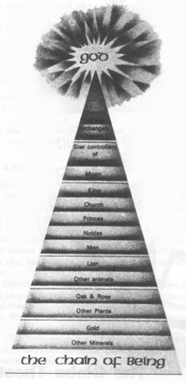 |  | 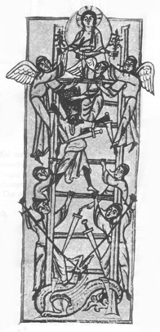
Why do you think humankind is placed between the angels and the animals?
TASK: As you read Macbeth, be alert to how the Chain of Being functions in the play, what the characters observe, and how they respond.

The Music of the Spheres
Another popular belief (that related to the belief in the Chain of Being was that the Universe was made up of a number of spheres contained within one another. All these spheres were believed to be made of a transparent crystal-like substance called aether.
The outermost sphere, in which all the stars were embedded, was called the firmament. Inside this outer sphere were a number of smaller spheres. They carried the sun, the moon and the planets. The earth was the centre of the universe.
The spheres were said to make musical sounds as they moved. These sounds were in harmony and showed the harmonious working together of the whole of creation. They were known as the Music of the Spheres.
The Divine Right of Kings
As God’s chosen representative on earth, the King was the supreme upholder of order on earth. As has been noted if his position was violated it would destroy the perfect order in the universe and bring strife and chaos to the world. For example, in Macbeth after Duncan is murdered we are told by the Old Man and Ross (Act 2 Scene 4) that the day became as dark as night, a falcon was killed by an owl and that Duncan’s horses turned wild and ate each other.
Any act of treason or treachery against the King was considered indirectly to be a mortal sin against God. The penalty was death. It was believed that:
Not all the water in the rough rude sea
Can wash the balm from an anointed King.
The breath of worldly men cannot depose
The deputy elected by the Lord.
(Richard III)
The Signs of the Zodiac
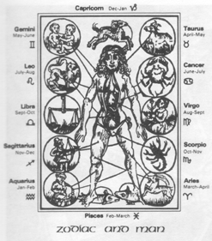
In Shakespeare’s day it was popularly believed that the fortunes of everyone and everything were affected by events in the heavens. The signs of the Zodiac were important to everyone. What star you were born under would determine what kind of person you would be and what sort of life you could expect.
The Four Elements and the Four Humours
There was also a strong belief that everything that existed beneath the moon was made from a combination of the four elements: Fire, Air, Water and Earth. The four elements had their counterparts in the four humours in the human body: blood, phlegm, melancholy and choler. If any of these humours predominated in the body they determined the mood of the man. Hence the expressions: “sanguine”, “phlegmatic”, “melancholic” and “choleric”. A balance of the four made for a “good-humour”; an imbalance made for an “ill-humour”.
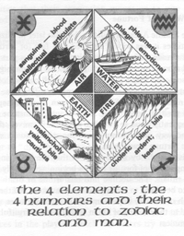  Element | Humour | Common Quality
Earth | Melancholy (yellow bile) | Cold and dry
Water | Phlegm | Cold and moist
Air | Blood | Hot and moist
Fire | Choler (black bile) | Hot and dry
When about to die, Cleopatra says: “I am fire and air; my other elements I give to baser life.”

The Wheel Of Fortune
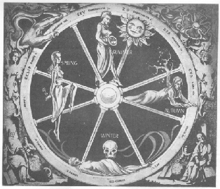
In the Middle Ages particularly, but also later in the Elizabethan times it was widely believed that Fate (or Fortune) was the main controlling force in life. Just as a part of a wheel moves from a low to a high position or from high to low, so does a person’s life. A person in a high position (such as a King, Nobleman or General) could expect (owing to a change in fortune) to suffer some disappointment or “fall”. Similarly, a person in an unhappy, lowly position could hope for a change in fortune and consequently rise to a higher position. However, there was no way of knowing where the wheel would stop, where fortune would lead.
It is thought by some scholars that the belief in the turning wheel of fortune had its beginnings in early seasonal rituals. The decline into misfortune or death was seen to be linked to the beginnings of autumn and the approach of winter; improvements in one’s fortunes were linked to the renewal of life in spring and the fruitfulness of summer.
This belief, like the belief in the Zodiac and the humours, tends to be in opposition to more humanistic beliefs that man could control his own destiny (fortune).
Humanism
A humanistic view of life is suggested in Cassius’ remark to Brutus:
The fault, dear Brutus, is not in our stars,
But in ourselves, that we are underlings.
(Julius Caesar)
In Shakespeare’s time a movement known as “Humanism” had a great influence on men and their philosophy of life. Humanists had great faith in man’s ability to shape his own future. They tended to shift the emphasis from life after death to life on earth. The term “Humanism” refers to thoughts and actions which are directed at improving society.
Fate
• life is predestined
• controlled by impersonal forces (gods, stars, unknown being)
• has effect on human lives
• what happens is not your fault
• is Shakespeare suggesting this in the play?
Task: As you read Macbeth, be alert to the role of Fate in the play, the characters’ attitudes to superstition and how they respond.
The Renaissance
The term Renaissance means “rebirth” or “revival”.
During the Middle Ages (roughly 1100-1400) the civilisation of ancient Greece and Rome had, to a large extent, out” in Western Europe. But starting in Italy in middle of the 14th Century and spreading throughout Western Europe during the next centuries, a revival of interest in Greek and Roman civilizations took place – a “Renaissance”.
England and for English Literature, the Renaissance meant more than an involvement in a rebirth of interest in ancient civilizations and cultures. The Renaissance also meant an exposure to the continental developments from the 14th to the 16th centuries. It also an awakening of Englishmen to their ability for using the heritage of the past and combining it with their n native gifts to produce a great new literary movement.
Perhaps more than any other Renaissance figure, Shakespeare revealed an ability to use the past and shape it his own dramatic needs.

