- Go to Explorer
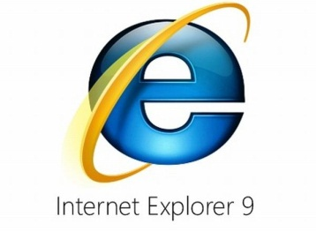
- Go to Home Page (at School)
- Or Go to AFNORTH SCHOOL Page (at Home) http://www.afnorth-is.com/index-1.html
- Go to Bottom of Left Green Banner and look for
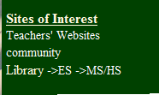
- Click on MS/HS and you will see this screen:
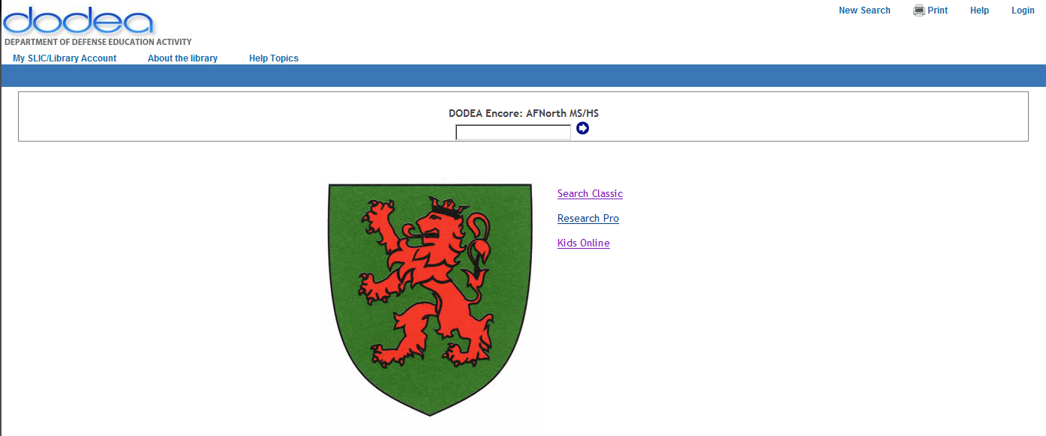
- Regular use of Web Catalog (Without login)
You can use the catalog by two ways
Type in your topic in the box
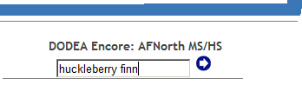

- Or Use:
Then you will see a screen where you can make choices to limit your search.
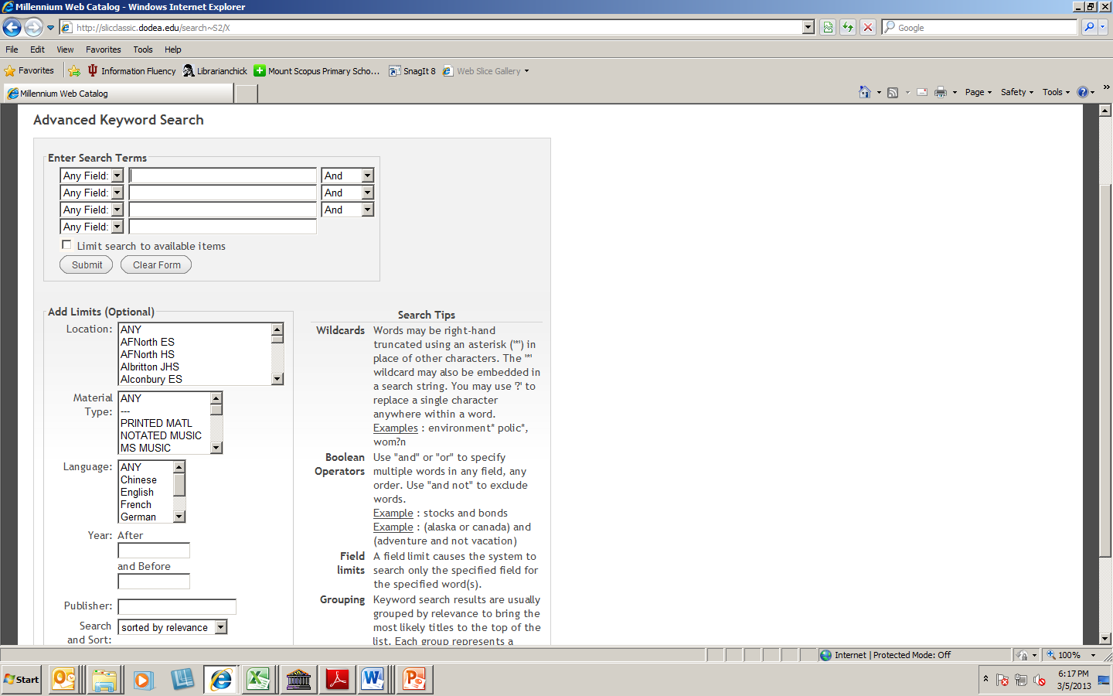
8. Next Screen
.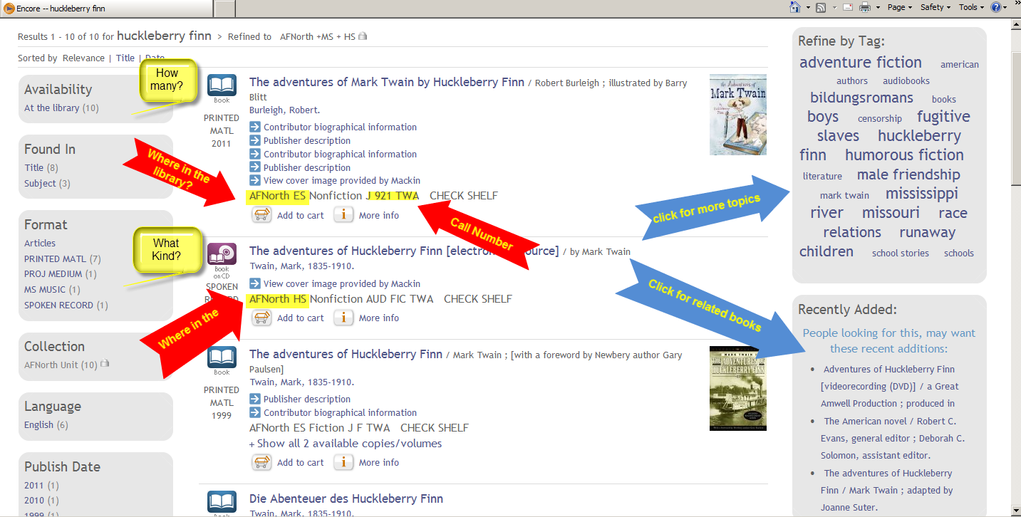
AFNorth ES refers to the Elementary Section AFNorth HS refers to the Middle-High School Section

Additional Items:
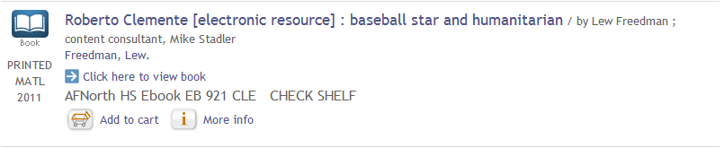
If you see EB in front of the call number it means that it is an electronic book that you read on your computer.
Some may be downloaded to a reader or laptop hard drive but most have to be read while in the Internet.

DATABASES:
Most databases can be reached by way of the new library system. For more sites go to
http://dodea.edu/Curriculum/inforCenters/hsLibrary.cfm
If the database needs a login and/or password use AFNORTH and DODEA
or visit the AFNORTH Homepage and click on Library Databases
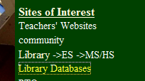
- Database Articles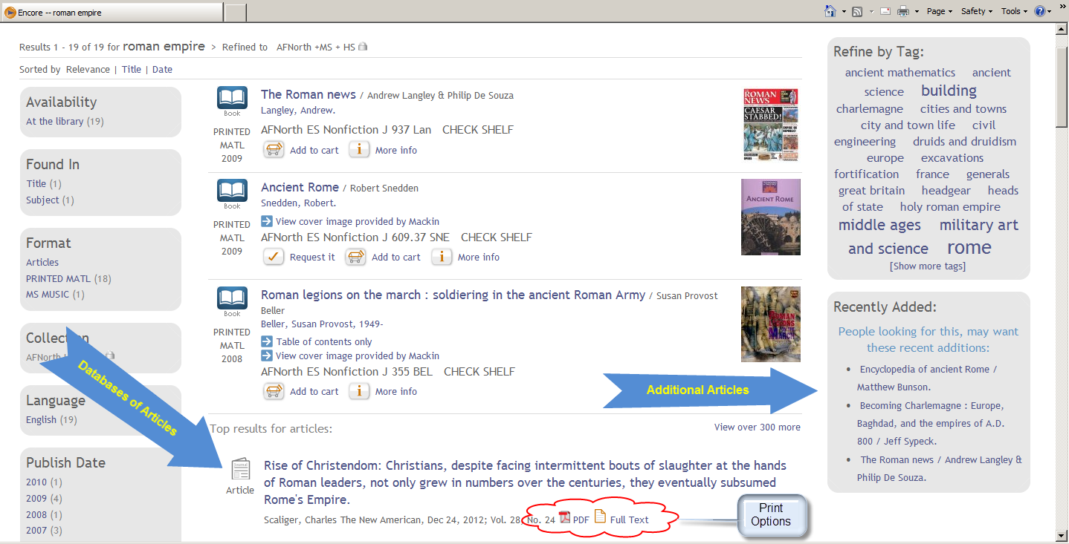

- Login Screen
You will need this for making a cart, a list or looking at some databases.
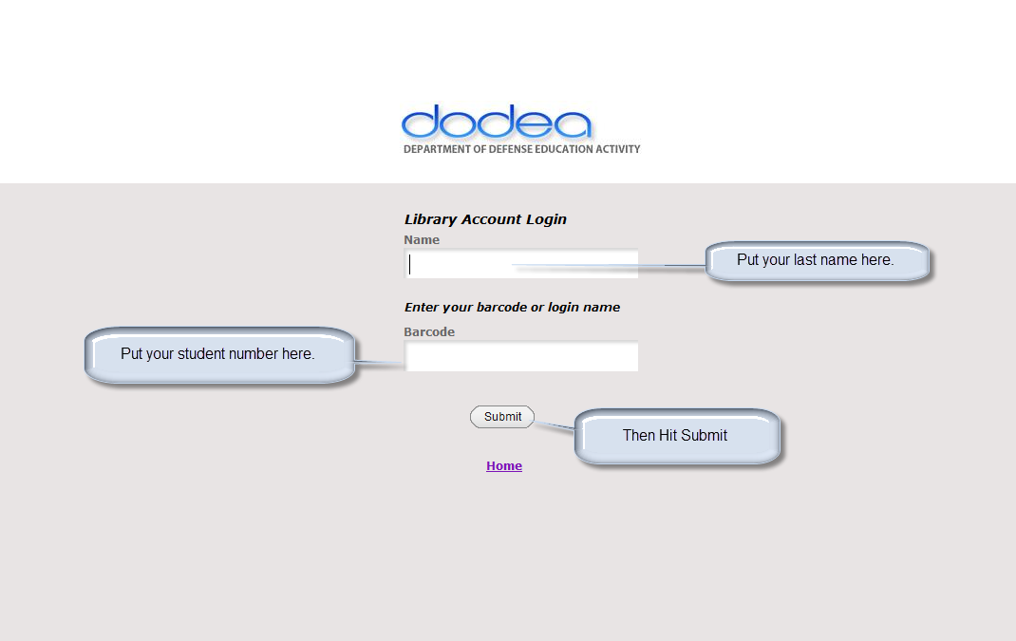
I will give you your student number if you don’t know it. If you don’t have one today, please use:
Name: Student Trainer Barcode: 12345678 (This will disappear later.)

- You can see the full article:
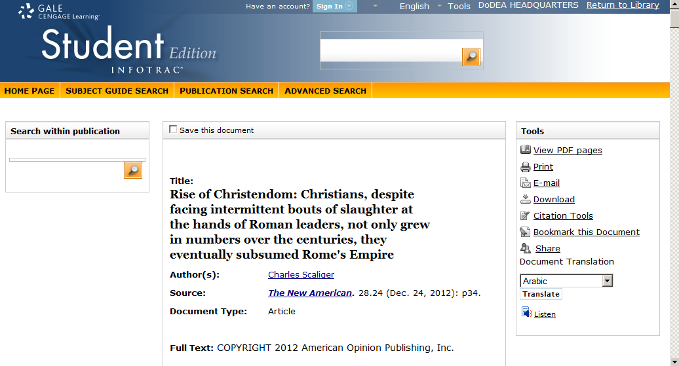

- You can use the list or cart options:
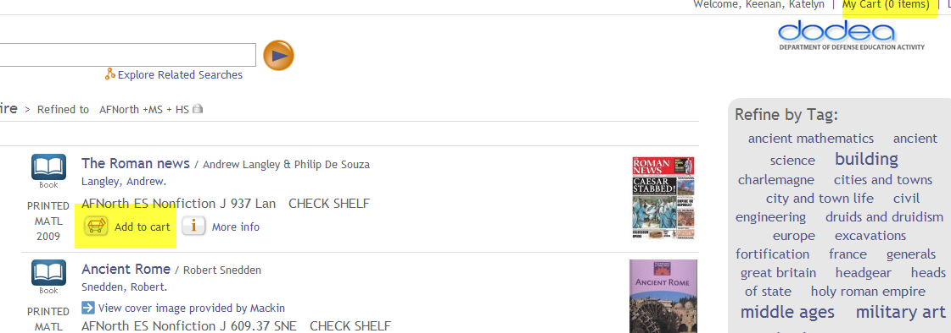

- Your Cart

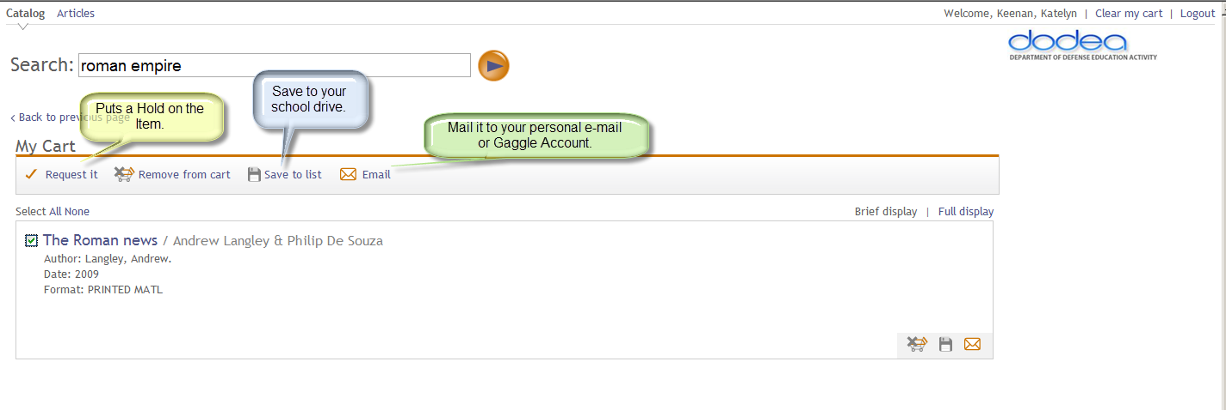
Or GMail

Additional Hints:

What the letters in front of or on top of the call number mean:

E means it is in the Elementary Section
(Fiction would mean it is a picture book)
(Non-fiction are mixed with the J non-fiction area)

J means it is in the Junior Section of the library either the Chapter books (Fiction) or Non-fiction area.
GE means it is in the German section and it is a German Language book.
FR means it is in the French language section either the back of the fiction (High School ) or in the Junior section
SP means it is in the Spanish language section either the back of the fiction (High School) or in the Junior section
PROF means it is in an area for teachers.
REF means it is in the Reference Area which is along the wall by the tables.

How does the Dewey Decimal system work?
DDC is an hierarchical number system that organizes all human knowledge into ten main categories.
These are:
000 Computer Science, information and general works
100 Philosophy and psychology
200 Religion
300 Social sciences
400 Language
500 Science
600 Technology
700 Arts and recreation
800 Literature
900 History and geography

Each main category is then divided into ten sub-categories. For example:
500 Science
510 Mathematics
520 Astronomy
530 Physics
540 Chemistry
550 Earth sciences and geology
560 Fossils and prehistoric life
570 Biology
580 Plants (Botany)
590 Animals (Zoology)

Each sub-category is then also divided into ten specific topics. For example:
530 Physics
531 Classical mechanics
532 Fluid mechanics
533 Gas mechanics
534 Sound and related vibrations
535 Light and related radiation
536 Heat
537 Electricity and electronics
538 Magnetism
539 Modern physics

Finding items on the shelves

The spine label will always have at least three numbers,
followed by some letters (first 3 letters of author’s last name.
It is usually displayed on the spine of the item.

612
NAG

Here are some examples:
The DDC system places items about the same subject at the same number. This means that once you have identified the DDC number for the subject you are interested in, you can browse the shelves at that number.
[Type a quote from the document or the summary of an interesting point. You can position the text box anywhere in the document. Use the Drawing Tools tab to change the formatting of the pull quote text box.]

133.4 133.54 302.23 510
ROS THO HAJ GLA

On each shelf the items are arranged in a numerical sequence from left to right by their DDC number. Where several items have an identical DDC number, the letters are used to further arrange them.
For example,

304.6 304.6 304.6
FAR JAN KRE
How to look for books on the shelves.
Remember the rule (It is just like you read the shelves just like you read a book)
Top to Bottom and Left to Right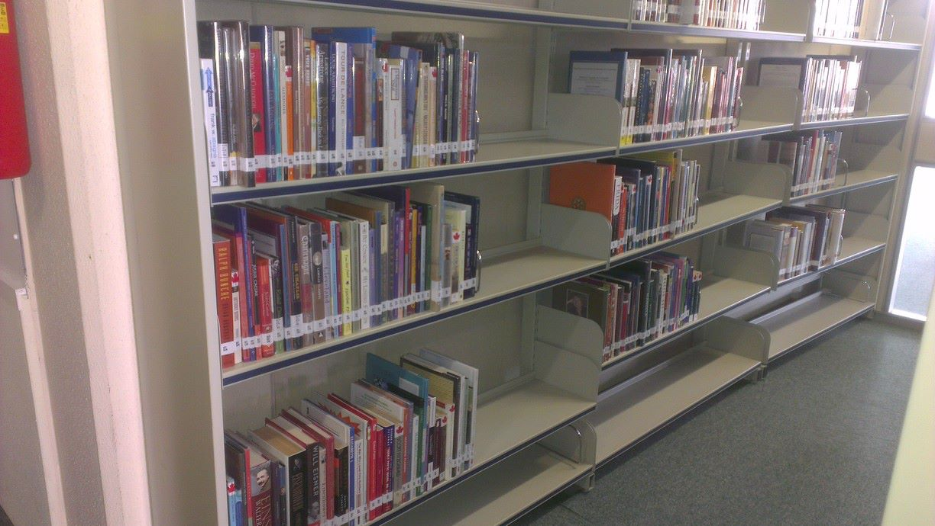

Other Library Classification Systems
While the Dewey Decimal Systems is the one most likely to be used in a school library most college libraries use the Library Congress System.
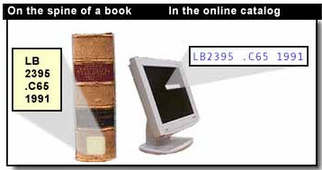
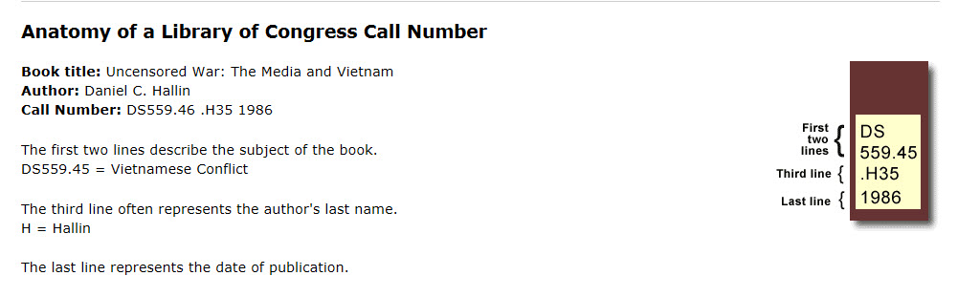

It is arrange somewhat different than the Dewey System but the main point is to be able to find a call number in the catalog and look for it on the shelves.
- A -- GENERAL WORKS -
- B -- PHILOSOPHY. PSYCHOLOGY. RELIGION -
- C -- AUXILIARY SCIENCES OF HISTORY -
- D -- WORLD HISTORY AND HISTORY OF EUROPE, ASIA, AFRICA, AUSTRALIA, NEW ZEALAND, ETC. -
- E -- HISTORY OF THE AMERICAS -
- F -- HISTORY OF THE AMERICAS -
- G -- GEOGRAPHY. ANTHROPOLOGY. RECREATION -
- H -- SOCIAL SCIENCES -
- J -- POLITICAL SCIENCE -
- K -- LAW -
- L -- EDUCATION -
- M -- MUSIC AND BOOKS ON MUSIC -
- N -- FINE ARTS -
- P -- LANGUAGE AND LITERATURE -
- Q -- SCIENCE -
- R -- MEDICINE -
- S -- AGRICULTURE -
- T -- TECHNOLOGY -
- U -- MILITARY SCIENCE -
- V -- NAVAL SCIENCE -
- Z -- BIBLIOGRAPHY. LIBRARY SCIENCE. INFORMATION RESOURCES (GENERAL) –

Additional Questions:
Copyright and Publishing Dates:

Is a copyright date the same as a publication date?
Sometimes yes, but generally no.
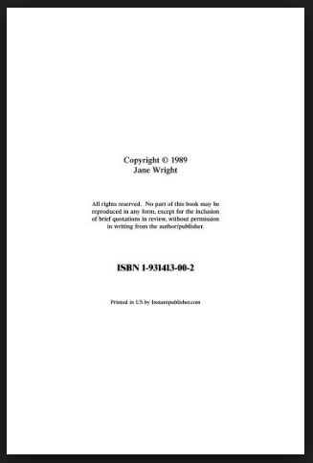
DATABASES
What to look for with DATABASES?
- Reliability
- Timelessness
- Relevance
Different Electronic Resources
Internet
CDs
DVDS
Fee-Based Databases
E-mails
Blogs
OPAC-online public access catalog
E-Books
E-Journals
Data & Statistics
Digitized Primary Sources
On-line Reference Tools
Indexes
E-Newspapers

Q. What’s the difference between bibliographic databases, bibliographic databases with abstracts, and full-text databases?
A. Most databases will contain all three types of results. They will also include ways to limit results in some way.
1. Bibliographic database: contains only a citation of an article or book.
Example: AFNorth Library System, database of books published which are in our library.
2. Bibliographic database with abstracts: contains a citation and an abstract (Summary)
Example: PubMed, the database of the National Library of Medicine
3. Full-text database: includes the full text of some articles or books, and citations for others.
Example: both EBSCOhost and OVID, and NCJRS, the National Criminal Justice Reference Service.

